

KickStart My Chart

Unit 1 Assignment

David Kreitzer | Data Visualization & Analytics | 8/18/2018

## What are three conclusions we can make about Kickstarter campaigns given the provided data?

1. The Parent Categories with the most successful projects did not raise the most Pledges.

Kickstarter raised a total of $40.6mm from successful projects. Of the successful projects, 87% of them could be considered Arts (including Music, Theater, etc.). Even though Technology projects only make up 9% of the total successful projects, they raised 48% ($19.6mm) of the total funds.

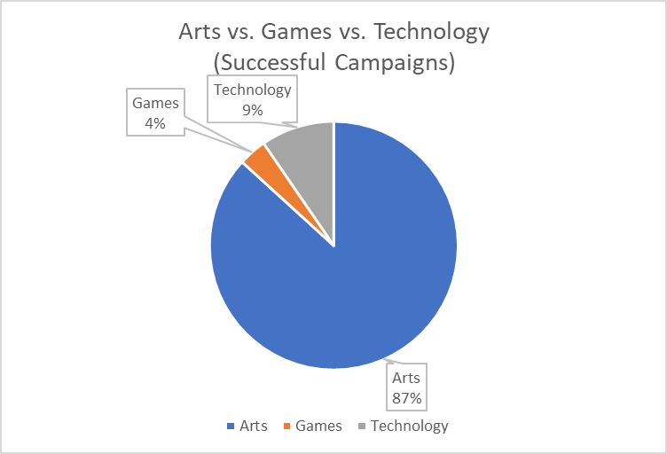 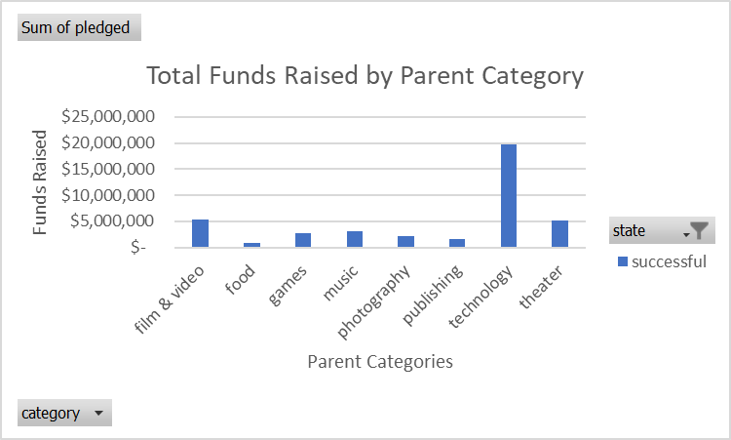

1. Creating a Spotlight Page might be the most important part of launching your project!

When I started to evaluate how creating a spotlight page and being a staff pick impacted a projects success, I assumed being a staff pick would have been a better indicator of whether a project would be successful or not.

According to the data, 100% of the projects that created a spotlight page WERE successful and 100% of the projects that did not create a spotlight page were NOT successful. Where being designated as a staff pick increased your chances of being successful, it was not enough to overcome not creating a spotlight page.

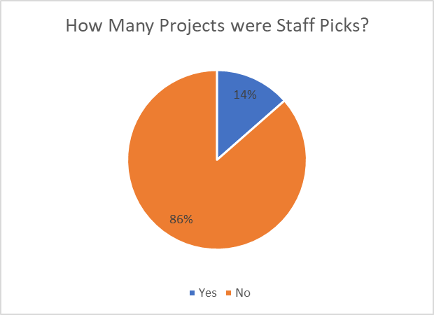 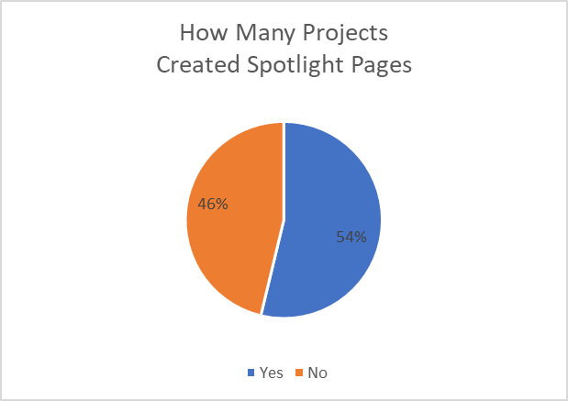

1. Projects Raising less than $15,000 have an increased chance of being successful. Where this isn’t necessarily true when evaluating each parent category individually, overall the projects with lower goals tended to be more successful.

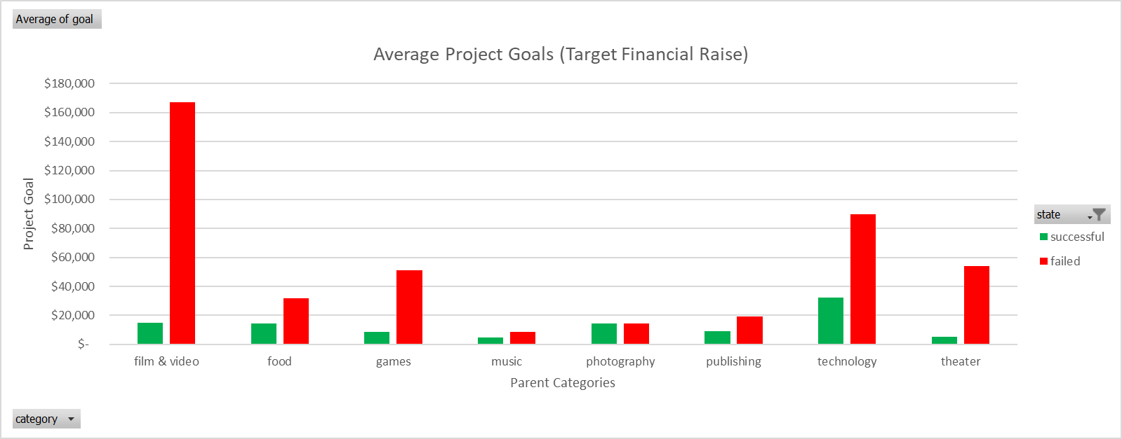

## What are some of the limitations of this datasheet?

### Sample Size

I was first curious about if the small sample size we are using is representative to the statistics available on Kickstarter’s website. Kickstarter was founded in April 2009 and according to their stats page, they have had more than 400,000 successful and unsuccessful projects. The Datasheet that we utilized for our analysis included approximately 4,000 example projects; so just a fraction of the whole sample size.

When grouping the total number of successful projects by >$1, 1k to >10k, 10k to >20k, and >=100k; both data sets of successful projects seem to be very similar.

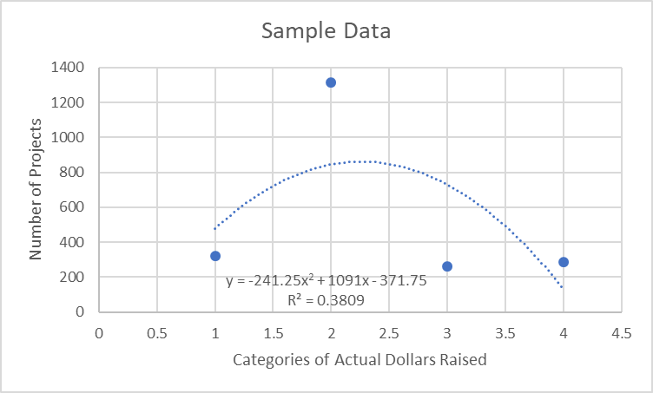 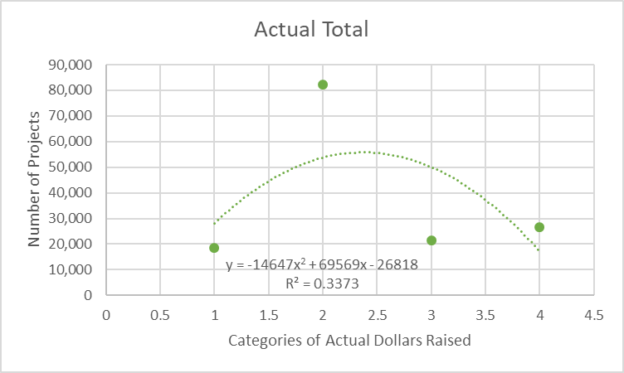

When only evaluating the total number of successful and unsuccessful projects, there was a much larger difference between the data sets. Where the sample data set shows 54% of the total projects being successful, the actual data set shows only 36% of the projects are actually successful.

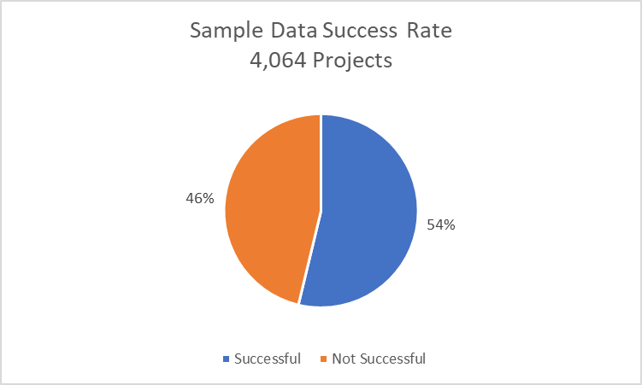 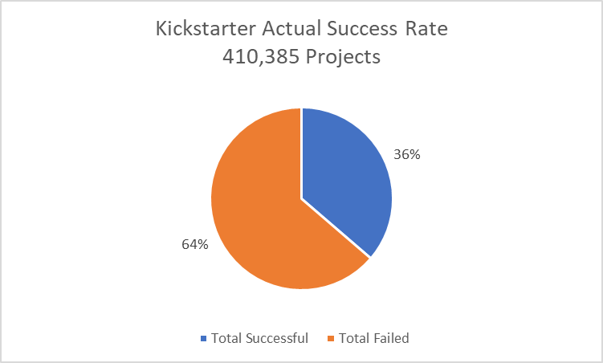

### Success Rate After Raising Funds

With both the actual and sample data set, something that is missing that would be very interesting to evaluate whether the company successfully fulfilled all of their orders. I was unable to easily find any data showing how many of the companies fail to perform after meeting or exceeding their campaign goal. I think it would be very interesting to evaluate which types of Parent Categories have the highest risk of not being successful.

## What are some other possible tables/graphs that we could create?

1. Scatter Plots

I was interested in if there was any relation to the projects goal and how much they actually raised.

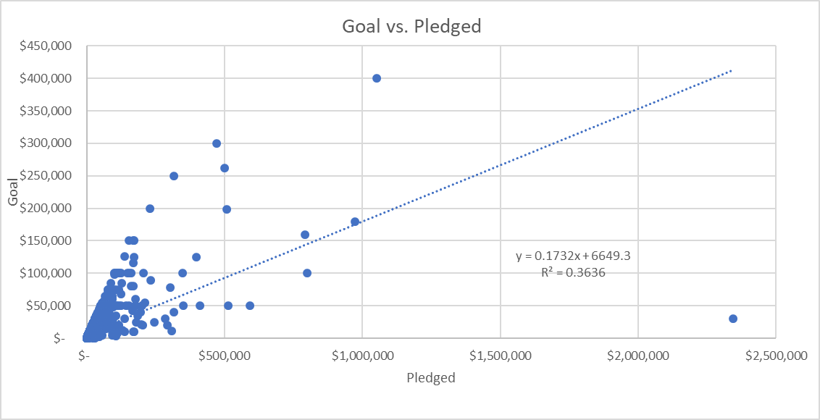

1. Layered Scatter Plots

I was curious how removing the projects that raised the most capital would impact the trendline and relationship. By removing the 10 most successful campaigns (measured by total dollars pledged), changed the intercept and slope.

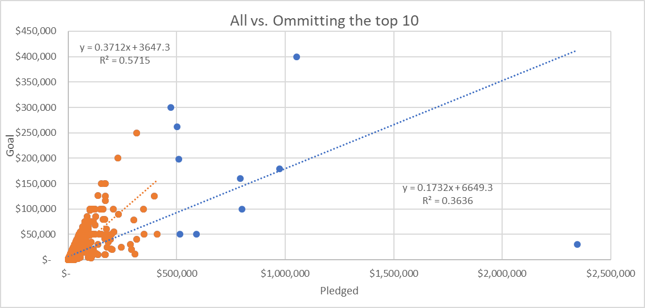

1. Tree Map

In my quest to find the countries that had the greatest project success rate, I created a Tree Map.

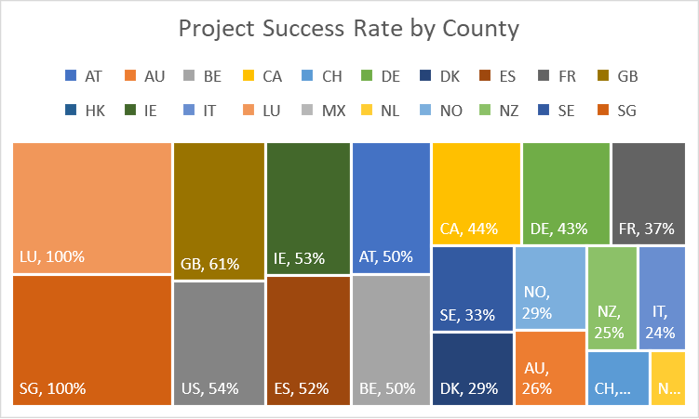

1. Stacked Area

I skipped a few steps in my efforts to identify the most successful Country and Sub Category to launch a new Kickstarter project; but this is a 3D Area graph I came up with that identifies the greatest chance of a project being successful. Why Theater in Great Briton? The average project goal was only $2,141, the average pledge didn’t exceed the goal that much with an average of $2,364. What stood out was that 77.3% of the projects that met these criteria were successful!

